Don't show anything related to payment once payment is done and verified

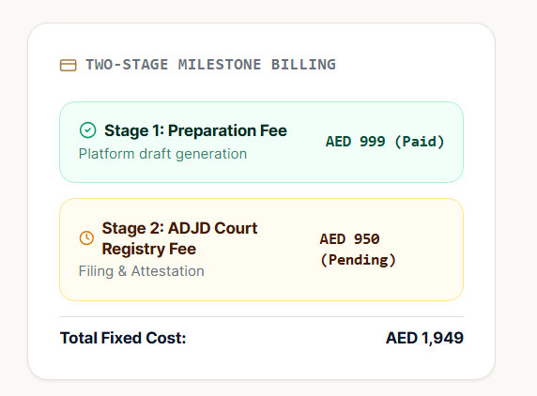

Need assistance or have any doubts

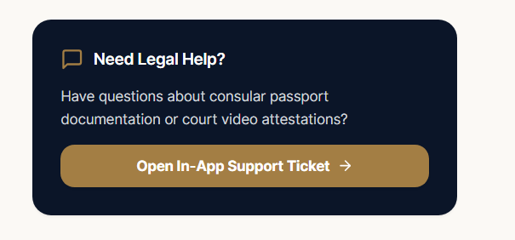

SCREEN 1 - Section A · Testator Identification & Document Verification

RESIDENTIAL ADDRESS HAS TO BE FILLED MANUALLY

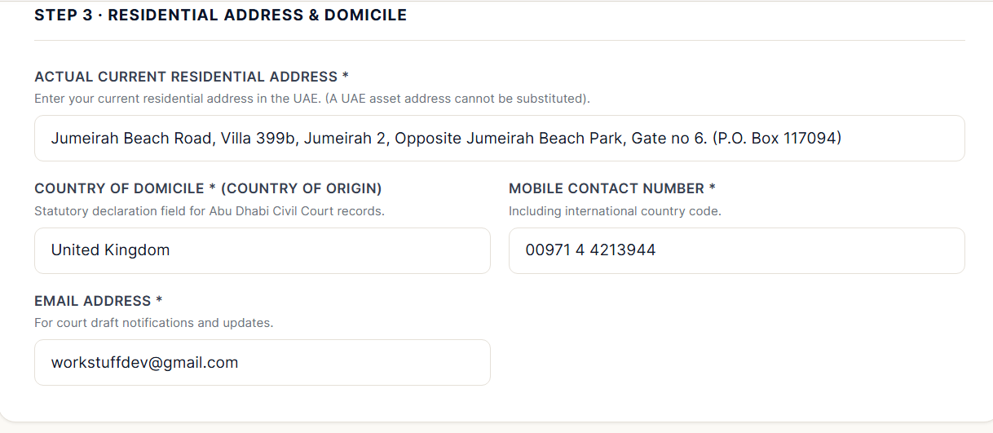

ADD - FOR COMPLIANCE PURPOSES


SCREEN 2- Section B · Children & Guardianship Eligibility

MOVE THIS UP BEFORE ADDING DOCUMENTS- SO WE CAN IDENTIFY IF BOTH EID AND PASSPORT ARE REQUIRED OR NOT

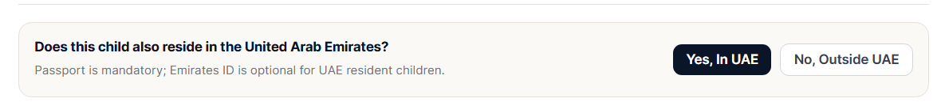

SHOW AUTO TRANSLATION IN GREEN ONCE DONE AND APPROVED IN ENTERED MANUALLY NAME

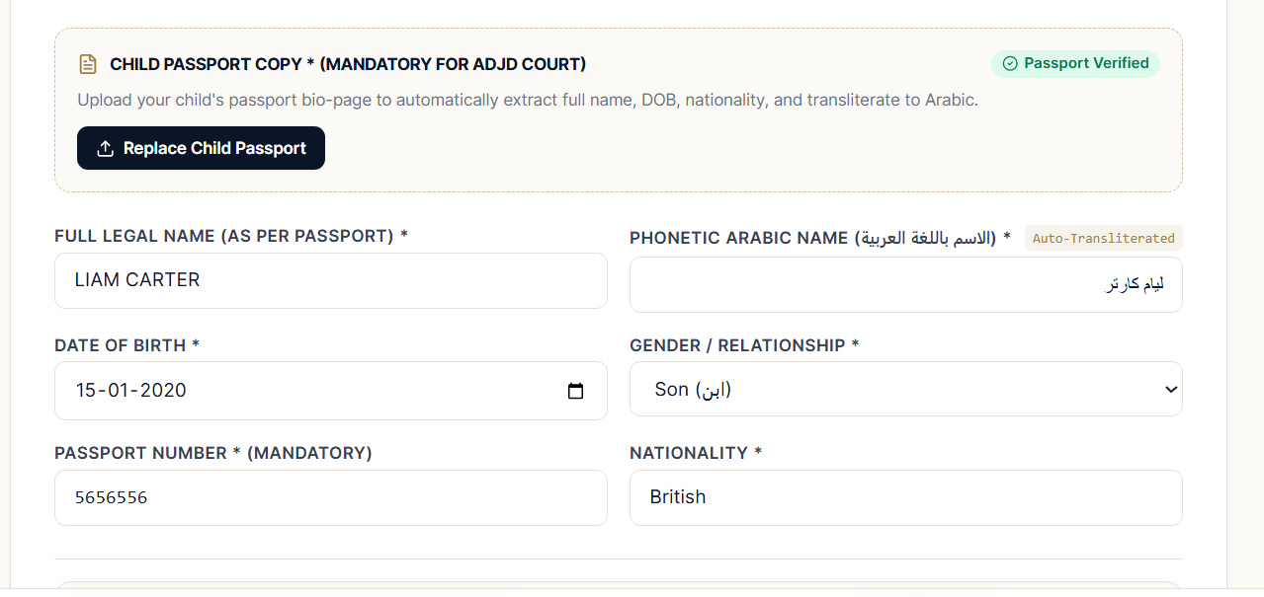

IF THE CHILD IS RESIDING IN THE UAE, KEEP THE EMIRATES ID MANDATORY TO BE UPLOADED AND INFORMATION IS DERIVED FROM THE DOCUMENT

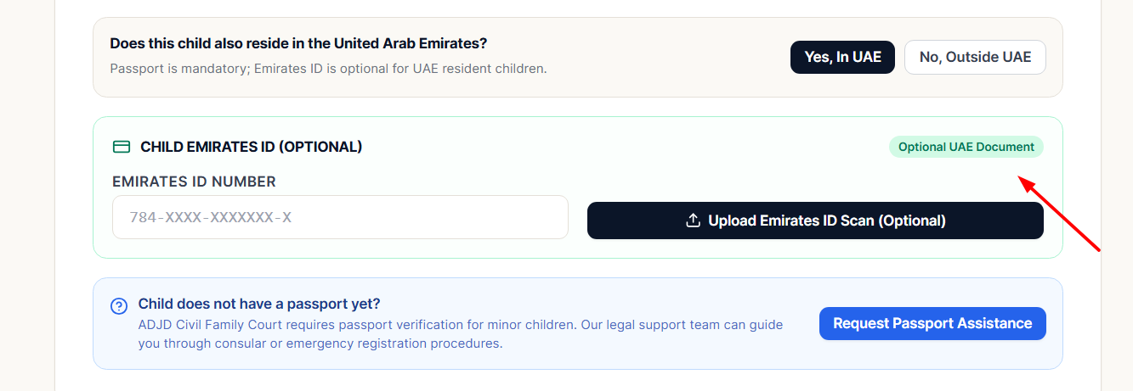

REMOVE THIS; NO NEED TO SHOW IF THEY ARE STUCK WITH SOMETHING THEY LL CONTACT ADMIN BY RAISING A TICKET

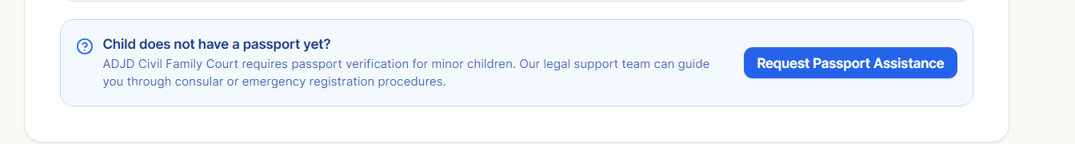

SCREEN 3 - Section C · Estate Administration

Appointment of Executors

ASK THE SAME THING BEFORE UPLOADING A DOC FOR EXECUTOR AS WELL AND Substitute Executor

DOCUMENT UPLOAD SHOULD BE BELOW THE ABOVE, AND THE REPLACE BUTTON IS NOT WORKING, AND CHECK FIELDS IF MANUALLY TYPING Relationship to Testator

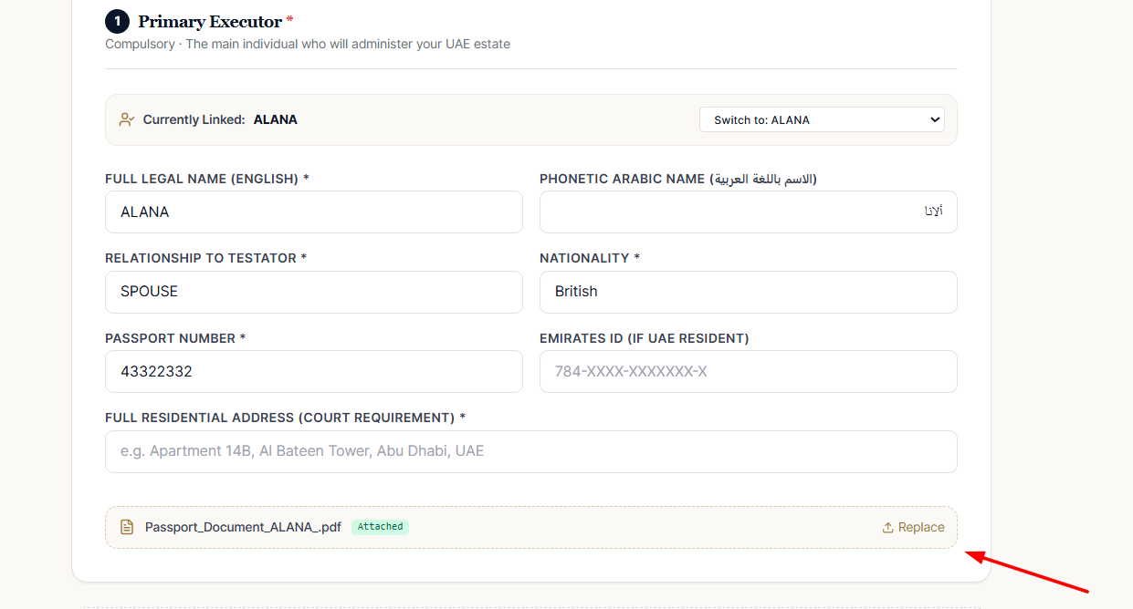

SCREEN 4 - Section D · Minor Guardianship

HERE, IF SOMEONE NEW WHO IS NOT PRESENT IN OUR SYSTEM COMES, THEN THE SAME QUESTION NEEDS TO BE ASKED: UAE RESIDENT AND DOCUMENTS UPLOAD. MOSTLY ITS WIFE, BUT IF THE WIFE IS NOT THERE, THEY WANT TO NOMINATE SOMEONE ELSE

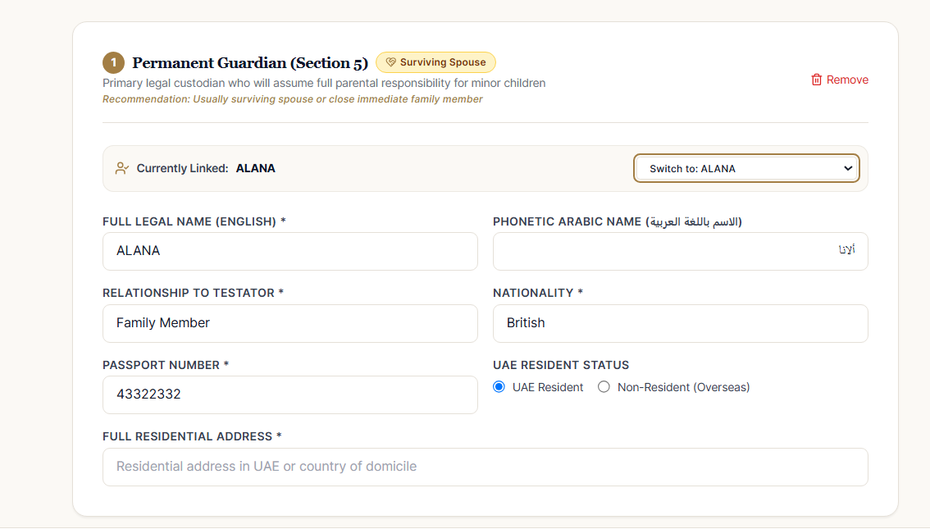

HERE ALSO UPLOAD AND SAME QUESTION

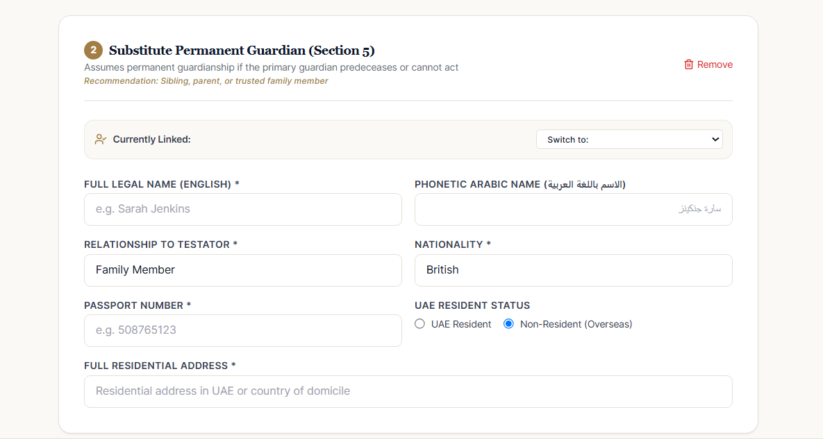

HERE ALSO

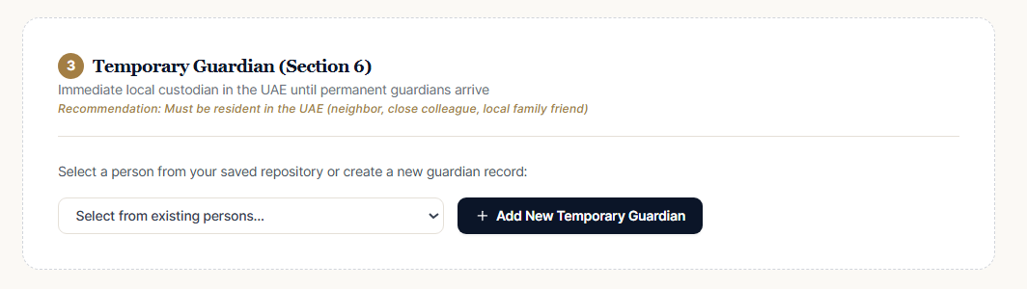

SCREEN 5

TYPING ISSUE
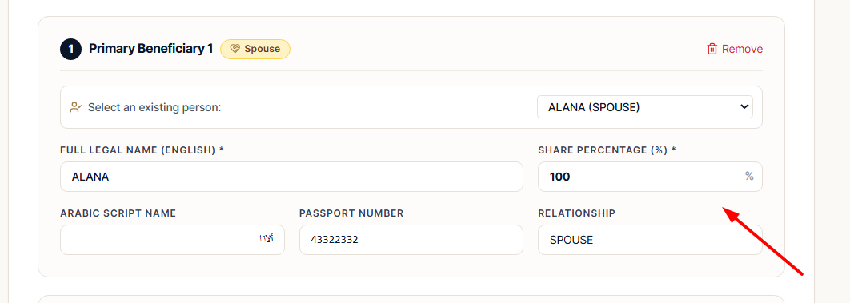

ADD A SIGN UPLOAD SECTION WHERE TESRTAOR HAS TO UPLOAD THEIR OWN SIGN AND WE WILL EXTRACT THE SIGN TO FILL FORM



